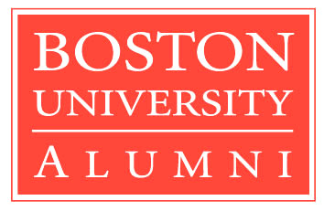 BU Now and Forever!!!

SUMMARY
OF
THE 1ST BU ASIAN ALUMNI FINANCE & INVESTMENT FORUM
March 9 &10 2007 in Hong Kong

Co-hosted By the BUAA Hong Kong & Korea

The large number of local and international attendees at the recent 1st BU Asian Alumni Finance and Investment Forum held on March 9 & 10 2007 in Hong Kong voted it an outstanding success. There were 6 from China, 4 from Japan, 14 from Hong Kong, 11 from Korea, 1 from Singapore, 3 from Thailand (for details, please see the list of participants attached herewith).

The Pre-Forum lunch was hosted on March 9 by Mr. Young Jae Han, Chairman of the Boston University Alumni Association of Korea at the Jumbo dimsum. A group of 11 Korean, 6 Chinese, and 2 Japanese alumni were welcomed at 1pm by Hong Kong alumni friends at the Restaurant. They exchanged their name cards and almost immediately become one group. Everyone was eager to mingle around the lunch tables to introduce themselves. The excitement was evident from all their smiles.

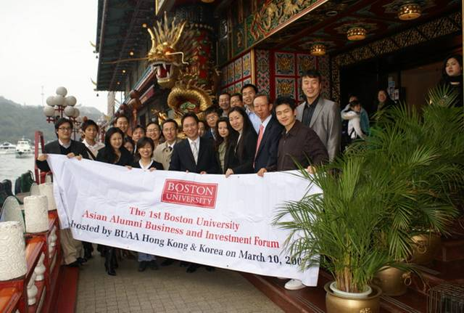
At the Jumbo after arrival in Hong Kong
The Pre-Forum Dinner was held at the Chinese General Chamber of Commerce at 7pm on March 9. The Korean group arrived earlier to meet up with Mr. Scott Nichols, Vice President from Boston University. The meeting was a bonus for the Korean alumni who participated in the Forum. Mr. Nichols welcomed Mr. Han’s strong leadership in the BU Asian alumni community and the Asian Alumni’s strong promotion of their networking development.

The Pre-Forum Dinner was hosted by Mr. Cheung (Wayne’s father) with a Feast of Chinese cuisine. Everybody was grateful to him for this generous hospitality which created a wonderful warm, friendly and welcoming air to the forum in Hong Kong.

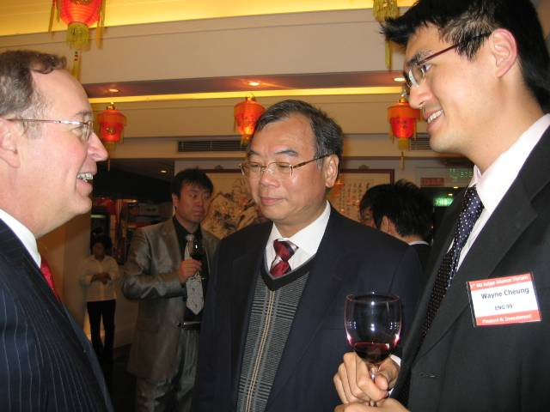
Mr. Scott Nichols Mr. Cheung Mr. Wayne Cheung

Before, during, and after the Dinner the attendees busily moved around getting to know each other. The value of discussions can be judged by the fact that they carried on even after they were rushed out of the restaurant, and continued while in the elevator and on the street waiting for a taxi. Some of the alumni had an extended time, talking and laughing until the next morning in a bar owned by a BU alum.

The 1st BU Asian Alumni Finance and Investment Forum started in the early morning of March 10 at the Renaissance Hotel Harbor View in Wanchai . The participants arrived on time with big smiles and registered in the forum where they could talk over light breakfast.

The Forum was officially opened at 10am by Wayne and Mr. Young Jae Han, the two co-hosts of the Event, and the opening was followed by the introduction of each participant.

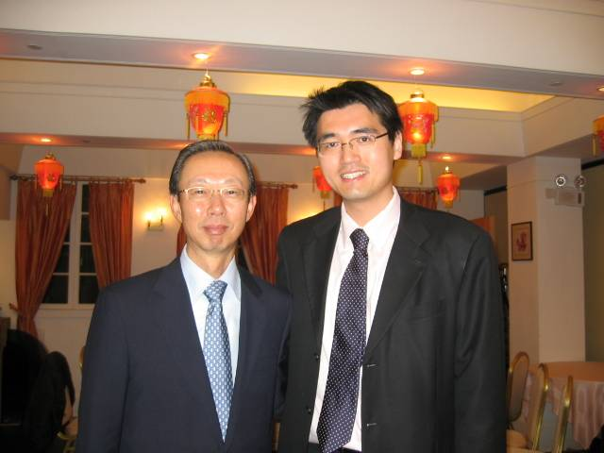
Two Co-hosts: Mr. Young Jae Han & Mr. Wayne Cheung
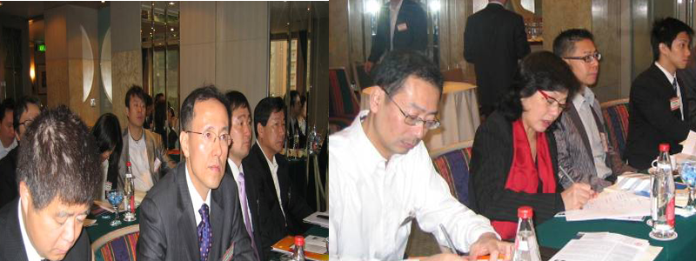

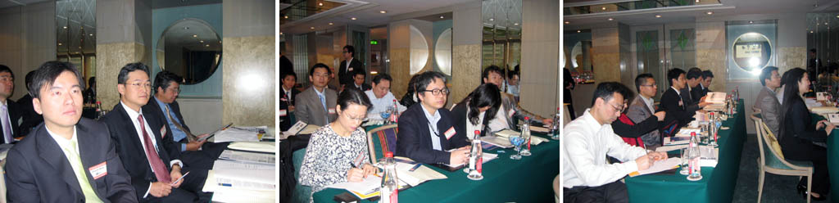
Forum Attendees ardently taking down notes

There were four (4) key note speakers invited and their speeches were all considered very useful guidelines for those who are interested in doing business in China and Hong Kong.

The speakers spoke on the following topics:

- Mr. David Kiang: Banking Issues in China
- Hong Kong Trade Development Centre: Hong Kong & China turning into opportunities
- Mr. Geoffrey Tang: Hong Kong Securities Market and Listings
- Ms. Elizabeth Qu: Legal issues of Foreign Investment in China

Four (4) Forum attendees made a presentation on their business opportunity as below:

- Mr. Henry Woo : Waste Gas Savings
- Ms. Caesara Niu: E-Bike Markets and special coatings
- Mr. Taeho Choe: BOAZ investment company
- Mr. Wenjing Ding: Medical equipment including tumor probing sticks.

The Forum ended at 4pm with Wayne and Mr. Han’s closing speeches.

A number of key senior members of the BUAA Japan (Mr. Koichi Yamazaki), Hong Kong (
Mrs. Juliana Kiang, Mr. Max Ma, Mr. Steven Chow & Mr. Michael Lee), Singapore (
Mr. Chor-chen Ang), and Thailand (Mrs. Somnual Laohaprasit) boosted the spirit of the forum by taking part in the event.

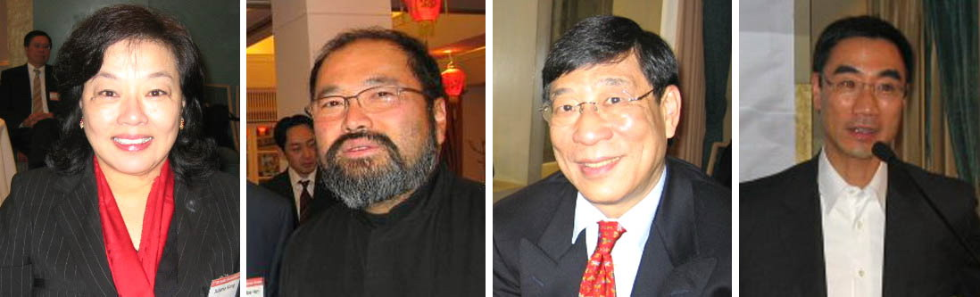
Mrs. Juliana Kiang Mr. Max Ma Mr. Steven Chow Mr. Michael Lee
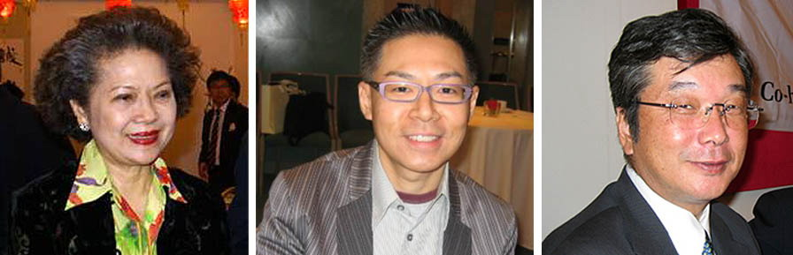
Mrs Somnual Laohaprasit Mr. Chor-chen Ang Mr. Koichi Yamazaki

Before the forum dinner at the Peak Lookout, there was a break in proceedings sufficient for those who wanted to do some shopping and we all reconvened at the Peak Lookout for a wonderful forum dinner at 6pm. Again it was a marvelous evening, thoroughly enjoyed by all. Mixing of our members and the genuine friendships made all contributed to the value and fun of the night.

The baton to hold the 2nd forum was handed over to the BUA China during the Forum dinner. A few key members including Mr. Vincent Wang, Mr. Rick Yang, and Mr. Jay Li based in Shanghai and Mr. Wenjing Ding based in Beijing are working on the legal issues that surround such an event in China, and they will contact the BU alumni individually soon to provide the forum details.

We encourage everyone please to come to the 2nd BU Asian Alumni Festival in Hong Kong to be hosted by the BUAA Hong Kong in November. The program will be distributed by Ms. Denise Hassan, Project Coordinator for the Festival in the not very distant future.

Clicking noises are around to exchange emails of friendship and ideas/suggestions/information that are the significant take home values of the forum. More gains to be hatched from our friendship and networks.

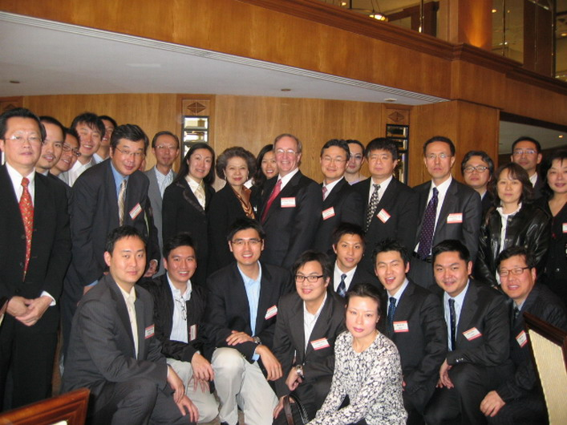

See you all again in Hong Kong in November 2007 and Shanghai in March 2008!

BU Now and Forever!!!!!!!

